SPEAKER:
Kent Perdrisat – Assistant Commissioner – Australian Taxation Office
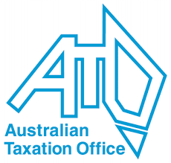
“Taxes are what we pay for civilized society …” - reportedly first said by US Supreme Court Justice Holmes, Jr. in a speech in 1927.
.
The ATO began in 1910 with George McKay as the first Commissioner of Taxation, who, in his first year, had underneath him 105 tax officers, assessed approximately 15,000 land tax returns and collected £1.3 to £1.4 million.
Compared to this, in the 2013–14 financial year, the ATO collected revenues totalling $480 billion in individual income tax, company income tax, goods and services (GST) tax, excise and others.

Until 1986, there were only small changes in the ATO.
However, in 1986 self assessment was introduced, bringing a massive change for Australian society.
In the late 1980s significant computerisation was introduced.
In the mid 1990s the Tax Payers Charter was introduced, heralding a change of direction form the ATO enforcing its authority to the rights of the taxpayer. Kent described Michael Carmody as a visionary to have brought this in at this time.
In 2000, GST was introduced, resulting in a huge task to design the administration of this.
More recently, the ATO has designed the system to be more use friendly and easier for people to comply with the ATO requirements. The MyGov website is one example.
However, 3,500 jobs have been shed with another 1,700 by 2018. Currently there are around 23,000 ATO employees.

Kent believes the ATO is now again on the cusp of reinvention, with the 12th and current Commissioner of Taxation is Chris Jordan, the first Commissioner who has not ‘come up through the ranks’. The ATO is becoming client focussed rather than just being ‘risk aversive’.

The ATO is heavily scrutinised as the importance of integrity in its system maintains it robustly corruption free.

