RIMERN Update … 4th March, 2022 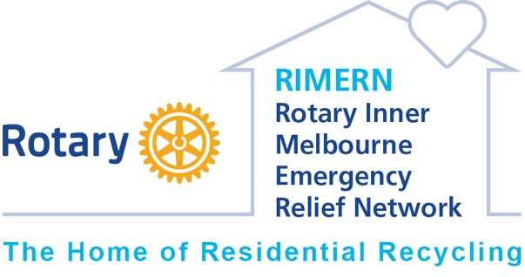

In the eight months since we opened the doors to RIMERN (Rotary Inner Melbourne Emergency Relief Network)’s East Brunswick warehouse we’ve made enormous strides!

- We’re a Registered Charity with full tax deductibility!
- We have 14 member Rotary Clubs (more are invited to join - just ask for a presentation at your Club!)
- We have 15 Welfare Agency members including Launch Housing, Melbourne City Mission, Wombat Housing Support, VincentCare, CoHealth, MiCare, Good Shepherd, Jesuit Social Services, Port Phillip Community Group and others referring bona fide clients in need.
- We have regular Club working bees that everyone enjoys & we are getting so much done!
- Several Clubs have gained new members from RIMERN volunteers!
- We’ve supported nearly 200 people coming out of homelessness, domestic violence & jail, refugees, people with mental health struggles and older Australians doing it tough.
- We’ve had wonderful donations of goods from individuals, companies and property managers so that what we’ve supplied to clients has been of amazing style and quality.
- We’ve succeeded in gaining a few Municipal Grants for capital expenditure
- We’ve had community groups fundraise for a commercial washing machine, dryer & Test & Tag unit
- We have nearly 700 supporters on our facebook page https://www.facebook.com/groups/495145215239091
(If you haven’t already ‘liked’ our page, please do so now to keep up to date with what we’re up to)

But now we really need our own VAN!

You can help us fundraise and raise a glass while you do it by buying some VAN ROUGE or VAN BLANC via this link
https://prospectwines.com.au/product/rotary-inner-melbourne-emergency-relief-network/
and by nominating a member Club (or no Club) you’ll be helping us hit the road to collect more great donations!

There are 6 quality Australian wines to order, choose one or all and delivery should take 4 – 7 business days.

Please share this link with friends, family, your social media networks (and anyone you know who enjoys a wine!), it’s all online, delivered to your door for $9 a dozen, the wines are top quality & very competitively priced so don’t visit your bottleo this month, please support RIMERN’s VAN!
