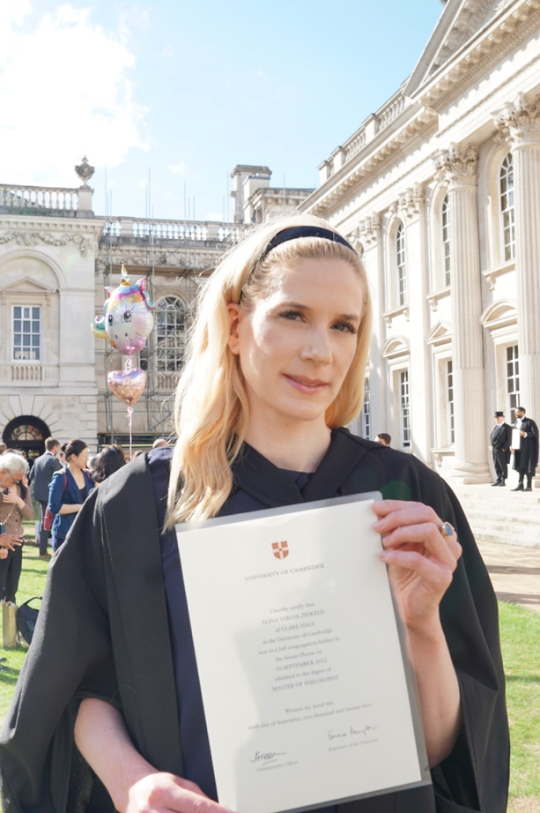

Good evening Rotarians, Global Grant Scholars and special guests,

My name is Elina and am the very fortunate recipient of a Global Grant Scholarship in 2020, which enabled me to complete a MPhil in Neuroscience at the University of Cambridge.

When I left Melbourne I was a junior doctor working at St Vincent’s Hospital aspiring toward a career in clinical research and hoping to help change the way we diagnose and manage dementia.

My experience in Cambridge really did launch my clinical research career. I am now working as an Academic Clinical Fellow in Old Age Psychiatry at King’s College London. This role allows me to simultaneously complete higher clinical training in old age psychiatry and continue to research dementia.

At the moment I am researching new MRI diagnostic markers of early Alzheimer’s Disease, and I’m hoping that this will enable us to test new treatments at an early stage in the disease when they are likely to be more effective.

I wish I could be there to toast with you all tonight.
I am certain that the new scholars are also going to have a very empowering experience abroad and I hope that I will get to meet them and hear about it in due course.
I hope everybody has a wonderful evening and that we can catch up again soon!

