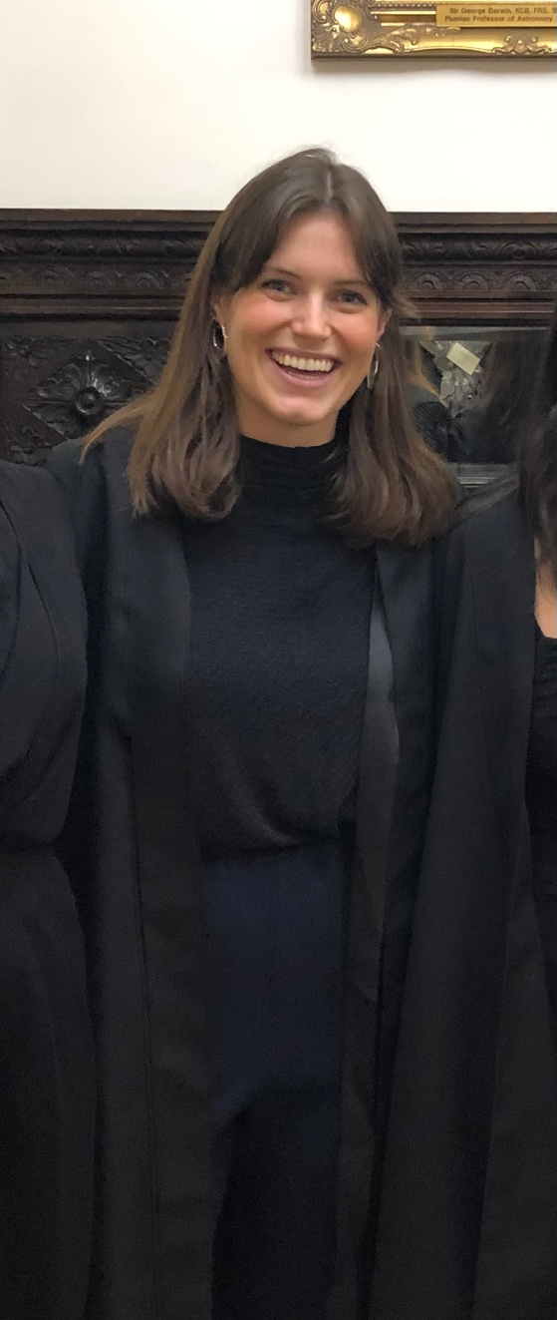
Dear Rotarians, Global Grant scholars and guests,

My name is Antonia and I have had the pleasure of spending the last year completing a MPhil in Criminological Research at the University of Cambridge. As the recipient of a Global Grant Scholarship in 2022, I am greatly indebted to Rotary for making this incredible experience possible.

Previous to arriving in Cambridge, I had been working in public policy for the Victorian Government on a range of different policy matters, including women’s economic security, crime prevention, family violence and violent extremism. Over the past few years, I have developed a strong interest and passion for improving women’s safety. Now that so much of our lives are spent online, women’s safety online is a growing concern and a global challenge. I was motivated to conduct further research into this issue, with the intention of applying my skills in a future career dedicated to reducing gendered abuse in all settings.

The past year at Cambridge University has allowed me to research women’s experiences of online abuse. I have had the opportunity to interview young women and learn about their experiences of abuse perpetrated online and through different technologies. It has been a great privilege to speak to young women about these issues, and I feel very grateful that they were willing to share these experiences with me. I am currently summarising my research findings into a final dissertation to complete the MPhil programme.

This past year has unlocked incredible opportunities for me. I have met wonderful people, formed new connections, and felt academically challenged. Once I complete the MPhil, I am looking forward to dedicating my future career to women’s safety. I am so grateful to Rotary for their support, and cannot recommend the Global Grant Scholarship more highly.

With best wishes,
Antonia

